**Hackathon Day-4**

**Day 4 – Dynamic Frontend Components Report for E-Commerce**

1. **Introduction**

This report outlines the development of interactive and responsive frontend components for **E-Commerce.** The key focus areas include:

* **Interactive Product Display**
* **Product card component displayed on the homepage**
* **Creating a structured and organized product listing page**
* **Designing a detailed and interactive product detail page**
* **Developing a fully functional shopping cart for order management**
* **Processing order submission on the checkout page and storing data in Sanity**

1. **Summary Of Tasks**

**Step 1: Developing The Product Component**

* Retrieved product data dynamically from the API.
* Fetched product data and presented it in a grid layout within a dedicated homepage component, highlighting names and prices.

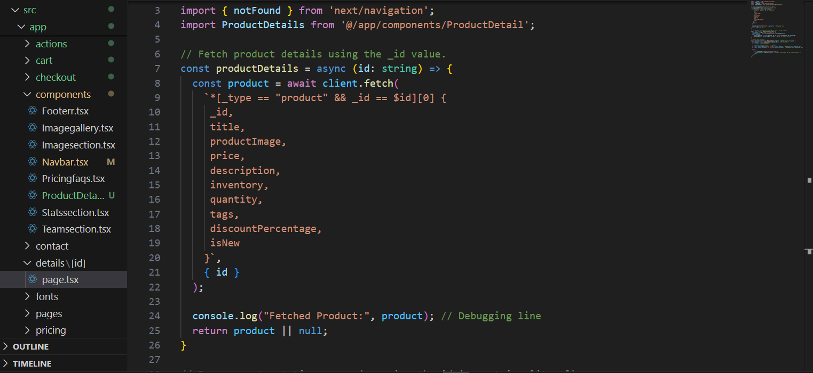

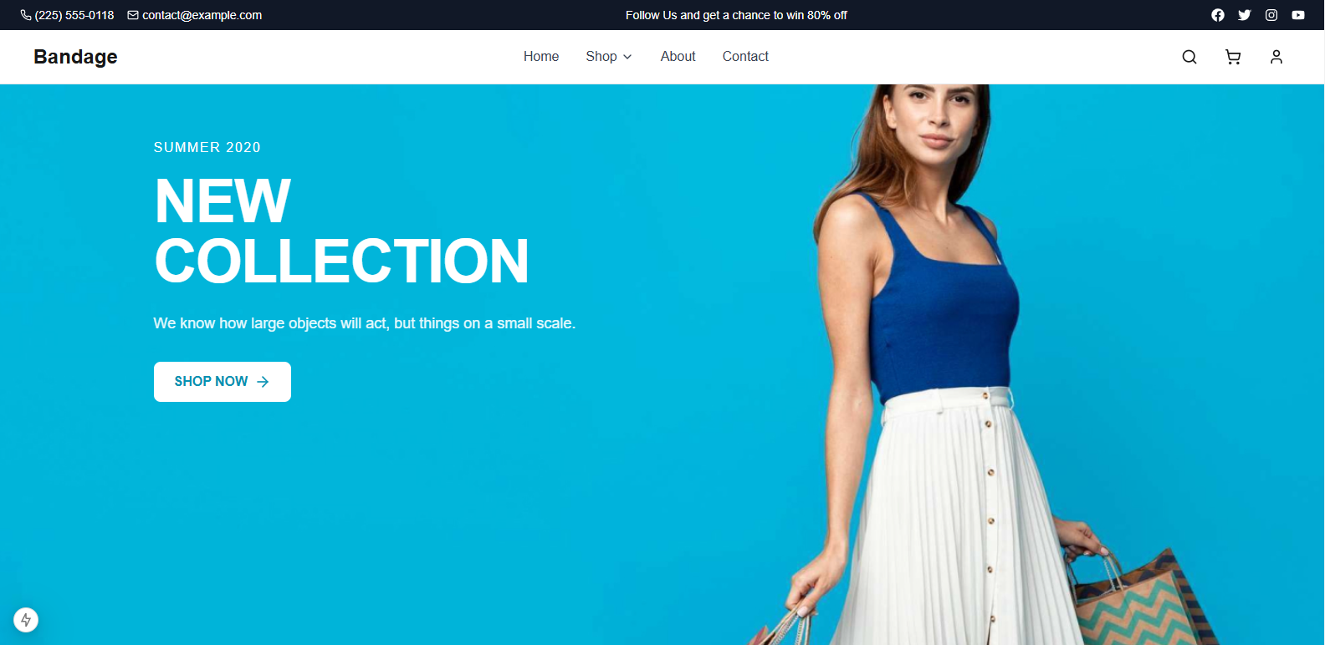

**Step 3: Creating the Product Listing Page**

* Retrieved product data dynamically from the API.
* Showcased products in a flexible grid layout, highlighting names and prices.

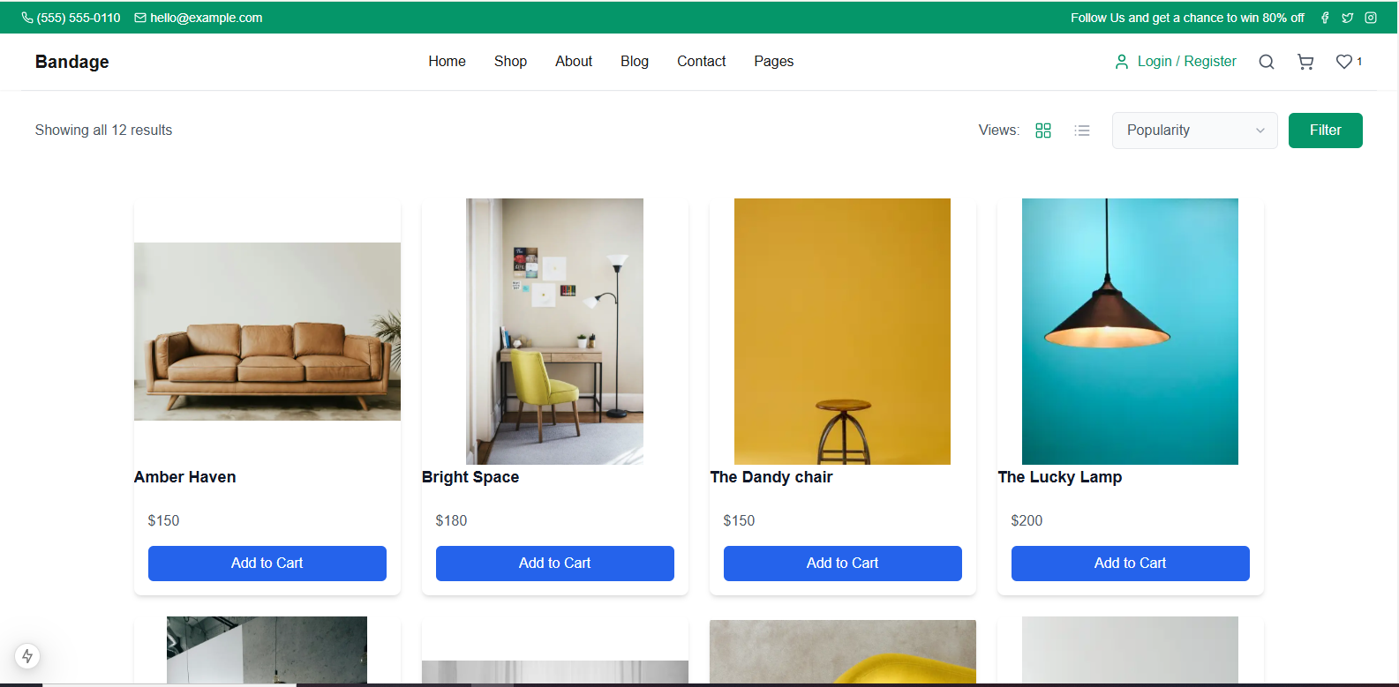

**Step 4: Product Detail Page**

* Developed a dynamic product detail page with individual routing.
* Implemented an "Add to Cart" button for seamless shopping. Clicking it successfully adds items to the shopping cart.

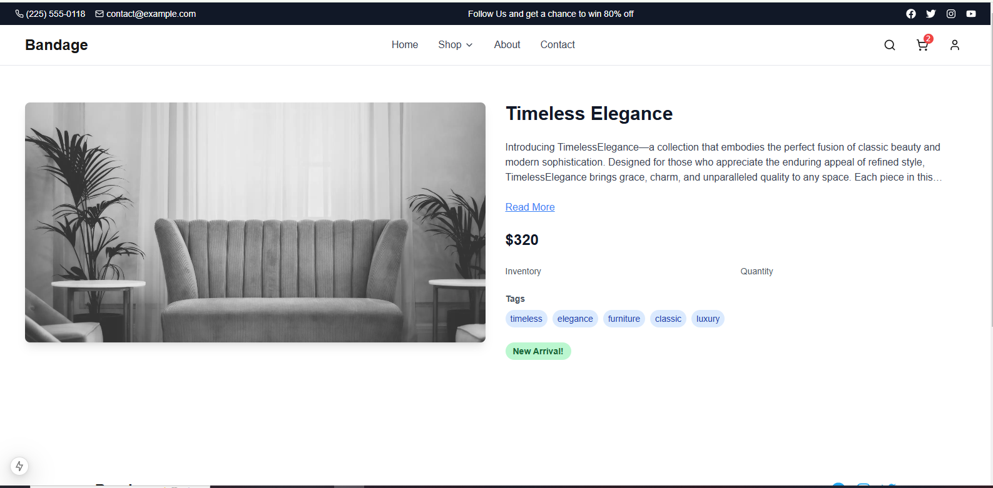

### Step 5: Implementing Shopping Cart Functionality

* Allowed users to seamlessly add and remove products from the shopping cart.
* Implemented real-time cart updates and a seamless checkout process.

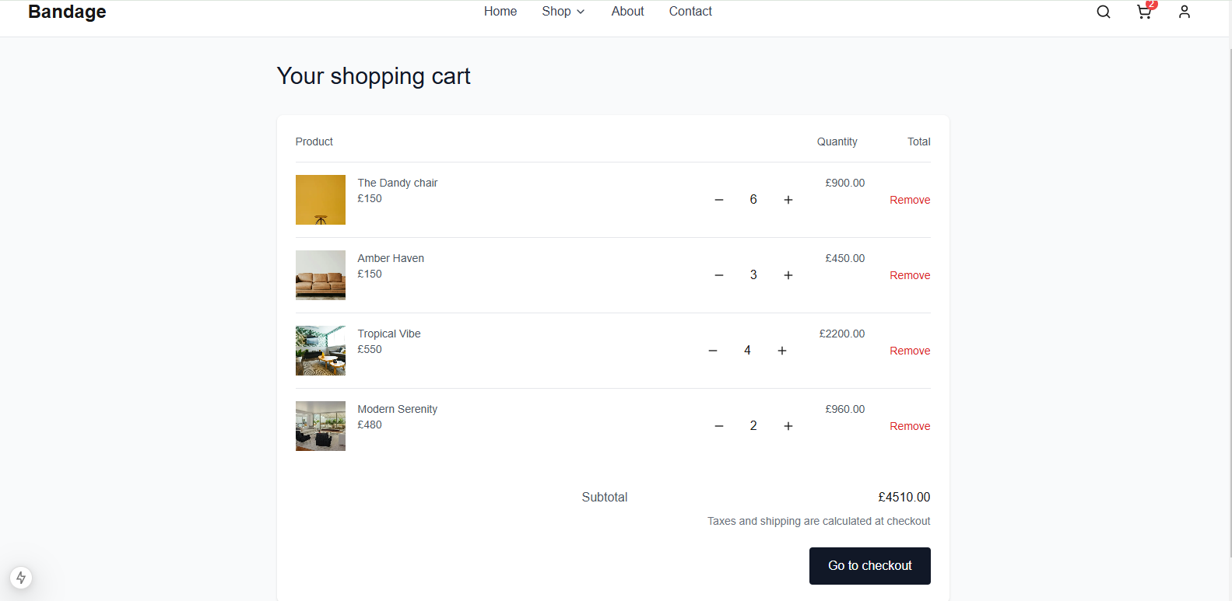

### Step 6: Successful Checkout

* Selecting the "Checkout" button navigates the user to the checkout page.
* Users can proceed by filling in their checkout details.

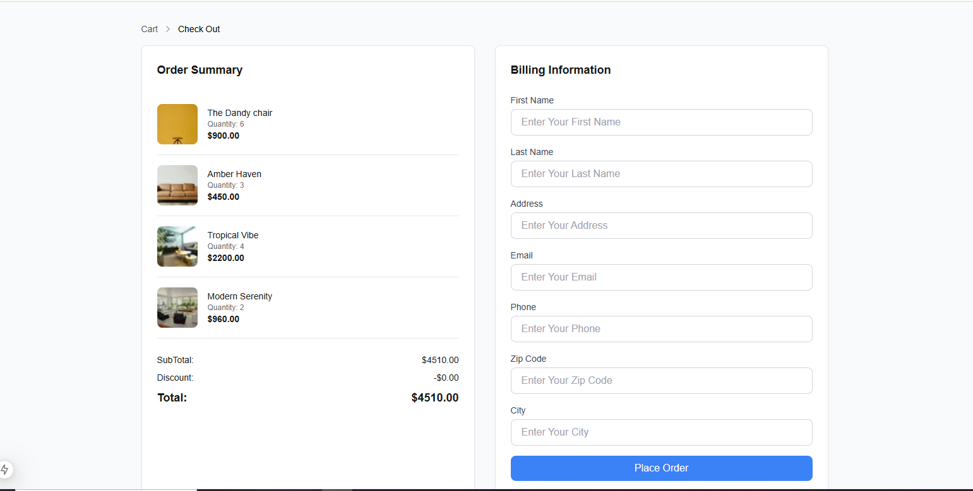

Placing an order on the checkout page will transmit the data to **Sanity.**

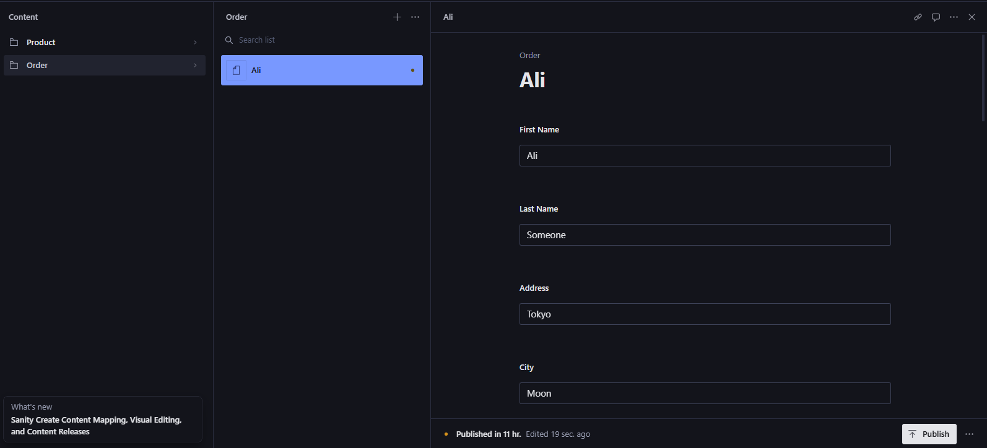

Below is a structured **Self-Validation Checklist** in table format, derived from your report. It offers a clear framework for verification and ensures all tasks are effectively completed.

**Self-Validation Checklist for Frontend Development**

**Frontend Component Development** ✔ ✘

* Interactive product display
* Fully functional product detail page
* Category filtering method
* Search functionality
* Shopping cart functionality (add/remove items)
* Order checkout functionality
* Authentication page ( Login / Signup )

**Design and responsiveness** ✔ ✘

* Responsive grid layout for product listings
* Consistent UI design across all pages
* Mobile responsiveness

**Code Quality** ✔ ✘

* Reusable and modular components
* Well-structured and maintainable code
* Efficient state management and data binding
* Performance optimization and fast loading speed

**Proper documentation and final submission** ✔ ✘

* Instructions for setup and application execution
* Well-documented code with comments and explanations
* Timely submission before the deadline

**Comprehensive final review** ✔ ✘

* Complete functionality testing (products, cart, checkout)
* UI/UX evaluated for a seamless user experience
* No bugs/issues identified in the development

**Adherence to professional development practices** ✔ ✘

* Well-structured and reusable component architecture
* Efficient state management and real-time data binding
* Adaptive and intuitive UI/UX design
* Comprehensive documentation for code and workflows

**Conclusion**

The interactive frontend components were successfully developed, improving the user experience with responsive designs and dynamic cart features. Attached screenshots confirm the completed implementation.